**NAME:AYESHA MUTTALIB**

**Q:What are the various types of operators in dart? Explain with Examples.**

**Operators in Dart:**

The operators are special symbols that are used to carry out certain operations on the operands. The Dart has numerous built-in operators which can be used to carry out different functions, for example, ‘+’ is used to add two operands. Operators are meant to carry operations on one or two operands.

Different types of operators in Dart:

The following are the various types of operators in Dart:

**Arithmetic Operators:**

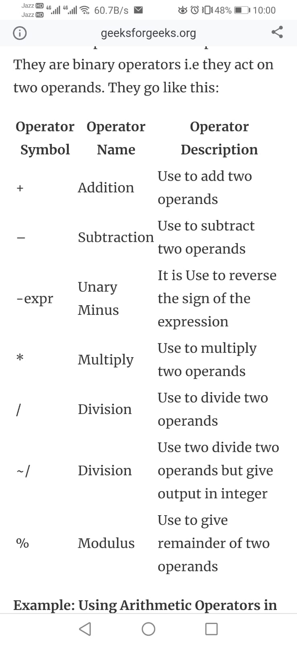

**Relational Operators:**

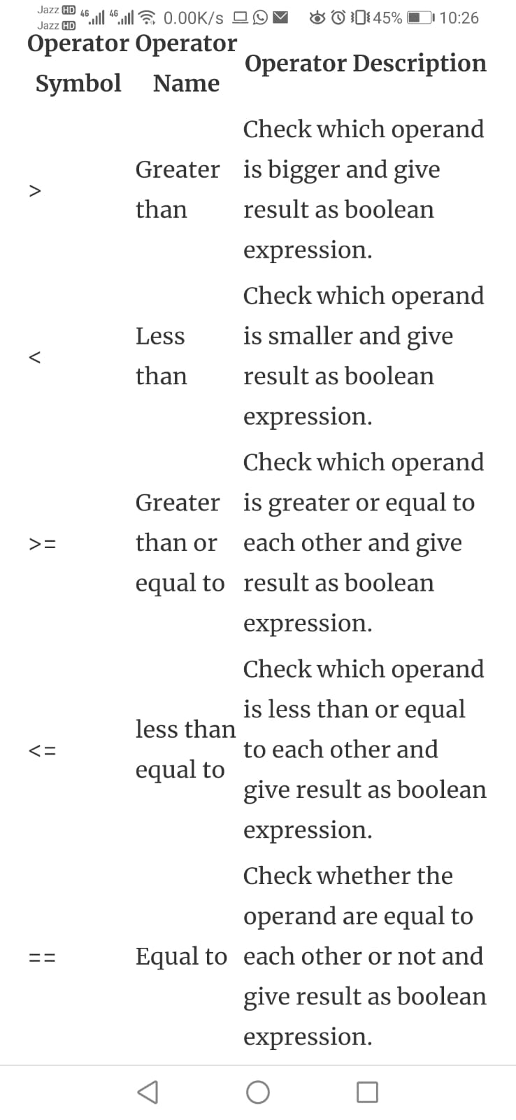

**Type Test Operators:**

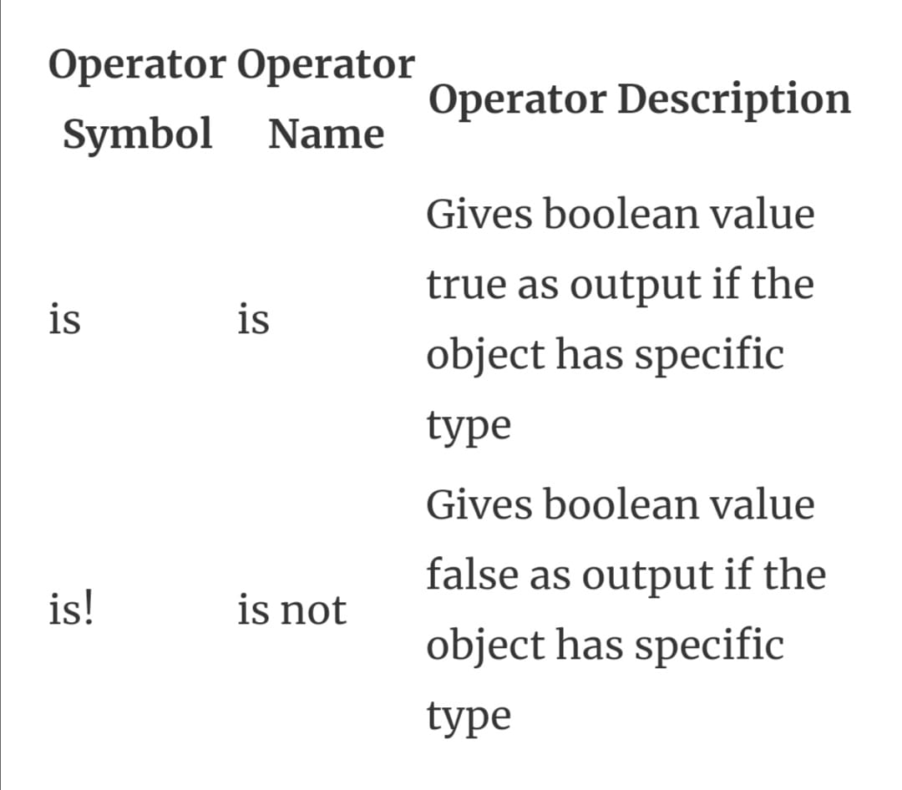

**Bitwise Operators:**

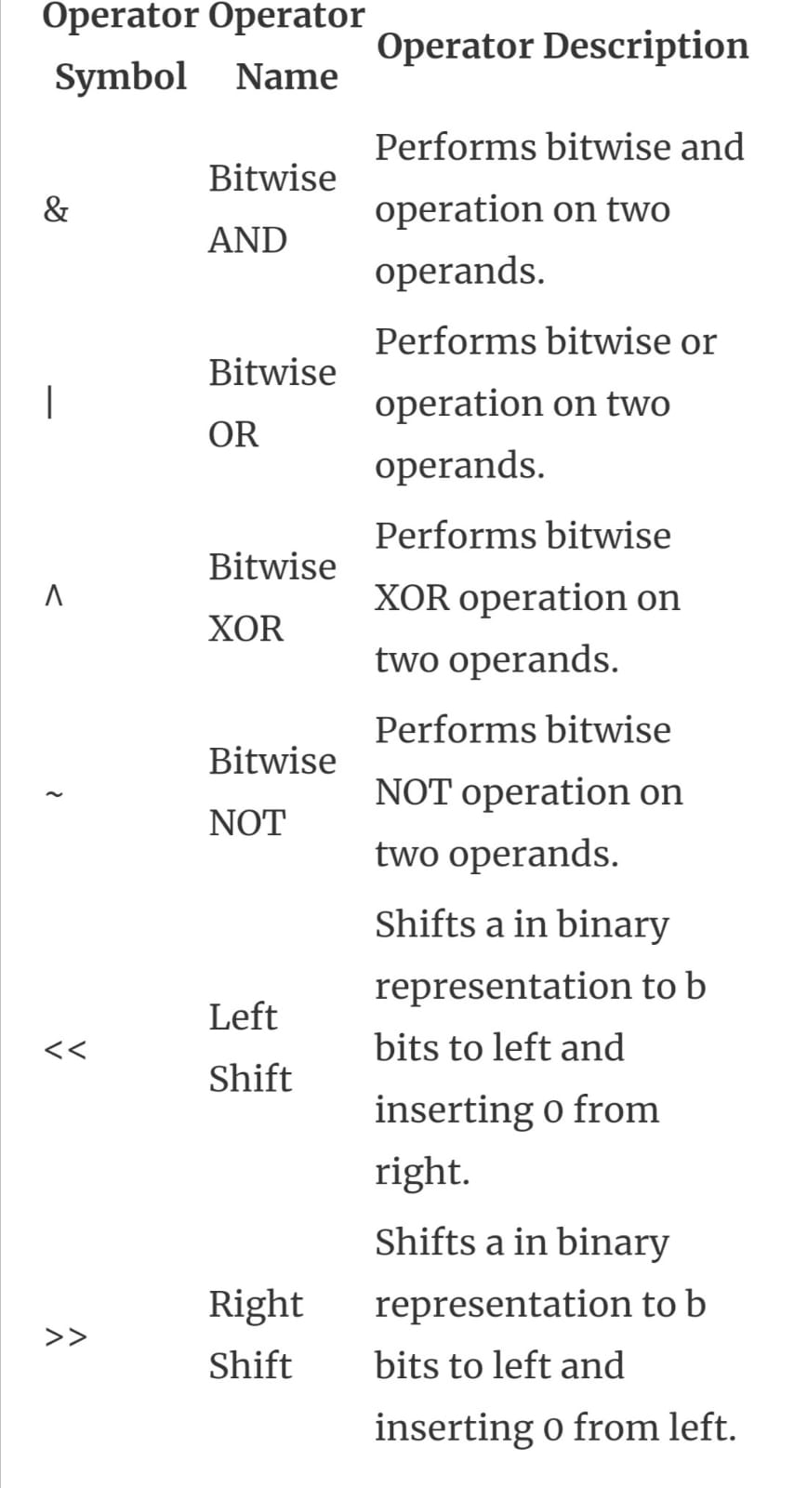

**Assignment Operators:**

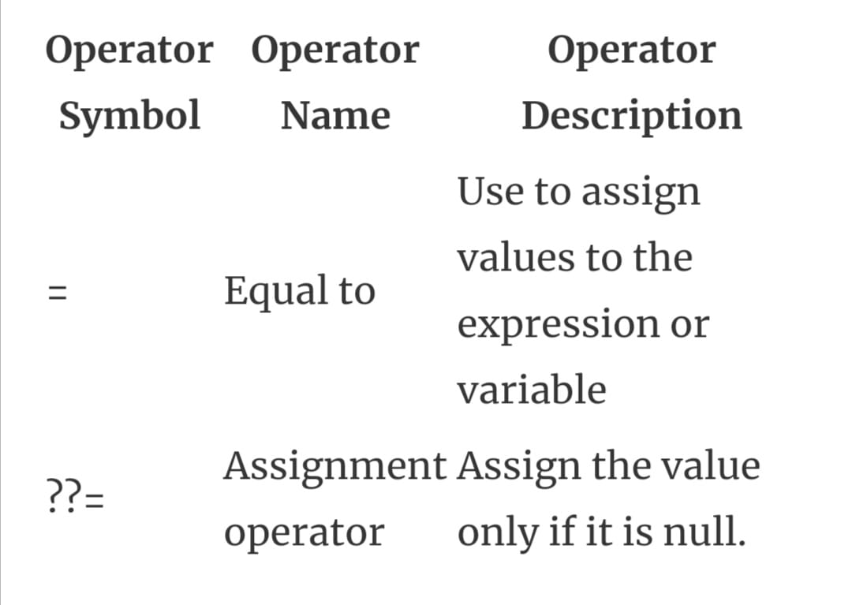

**Logical Operators:**

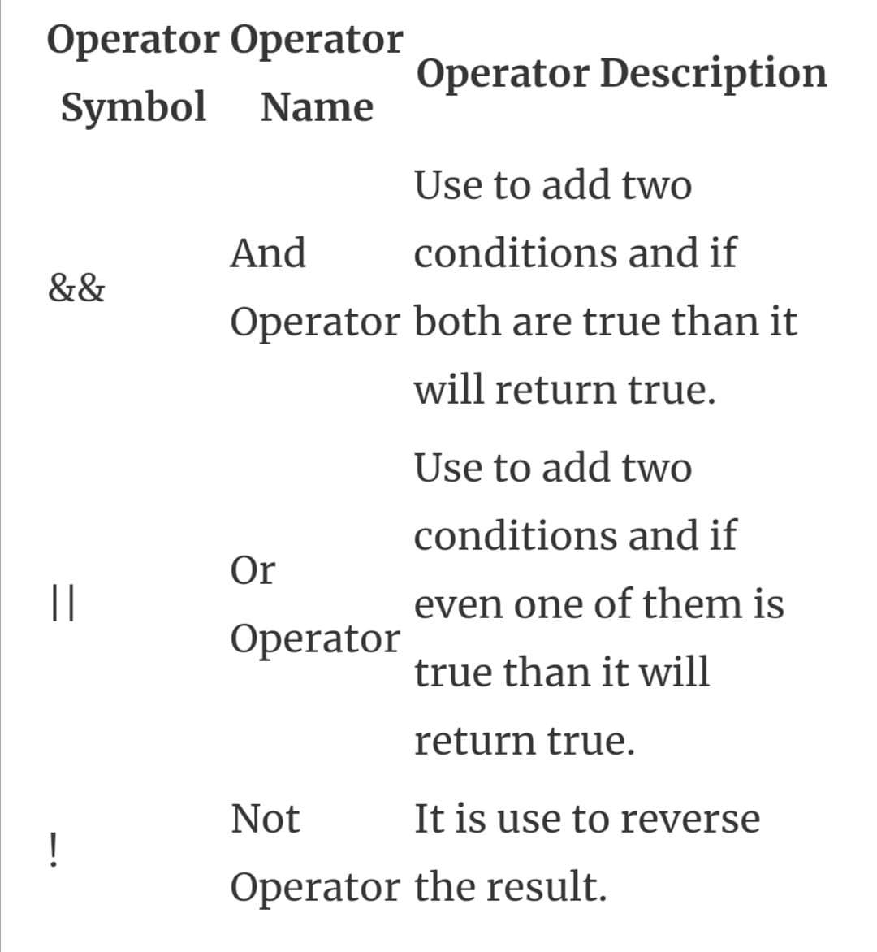

**Conditional Operator:**

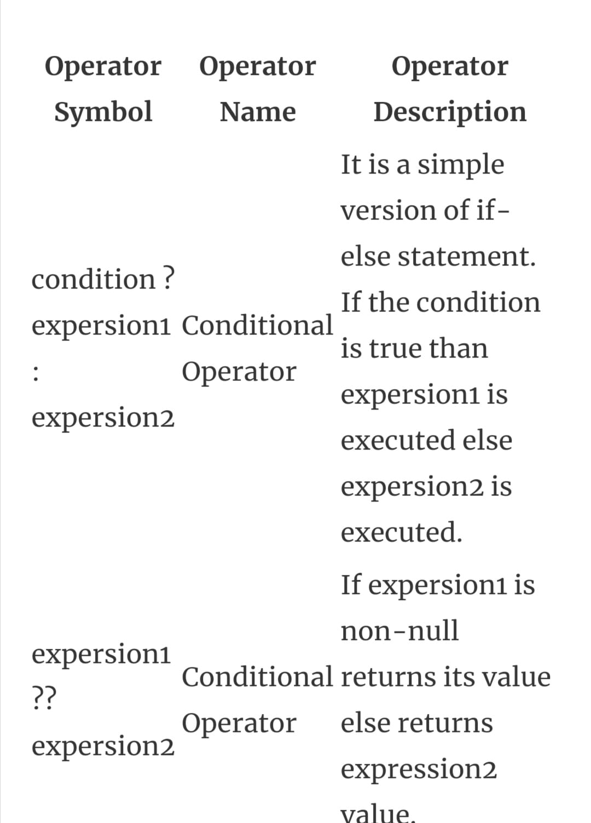

**Cascade Notation Operator:**

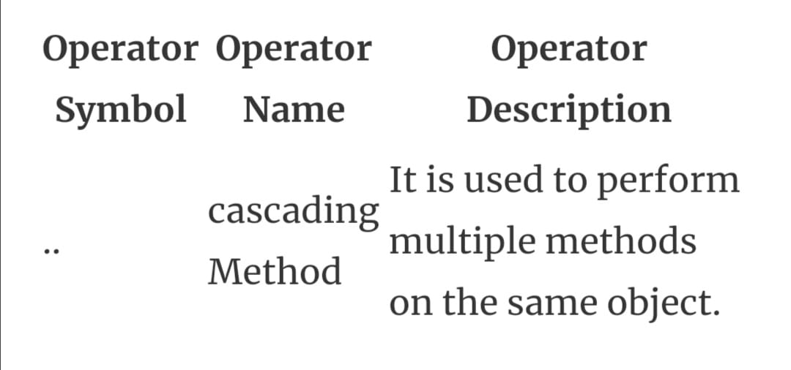

What is a difference between these operators “?? And?”

“?”:

It is a simple version of if-else statement. If the condition is true than expersion1 is executed else expersion2 is executed.

“??”:

If expersion1 is non-null returns its value else returns expression2 value

Q:What are the data types supported in Dart? Explain with Examples.

DATA TYPES:

Data types which are supported in dart are:

Numbers:

Int:

int no = 123;

**Double:**

double number1 = 12.33;

**Num:**

num number2 = 27;

String:

String names = "ayesha";

**List:**

List values = [1, 2, 3, 4, 5];

**Map:**

Map<dynamic, String> user = {};

**Var:**

var name = "string";

var number = 123;

**Bool:**

bool b = false;

bool c = true;

Q:Declare 5 legal & 5 illegal variable names.

**ILLEGAL:**

var 123="sdd";

var &name="wtet";

var name.ty=123;

var 123fgg="dfd";

Var my-name="fatima";

**LEGAL:**

var name123="sdd";

var name="wtet";

var name_ty=123;

var _names="dfd";

var no$fj="fatima";

Q:Find 5 new methods of List and String.

List method:

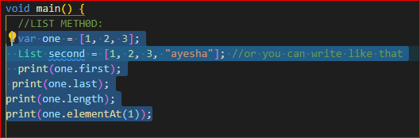

UPDATING LIST:

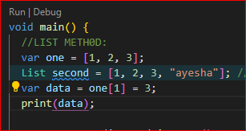

**Replacing list element:**

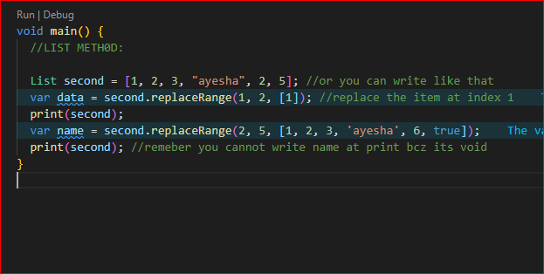

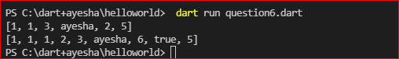

**Sort:**

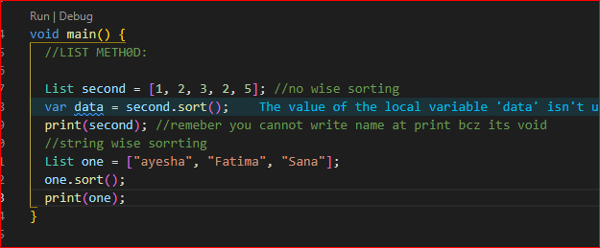

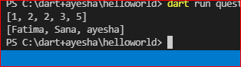

**isEmpty & isNotEmpty METHOD:**

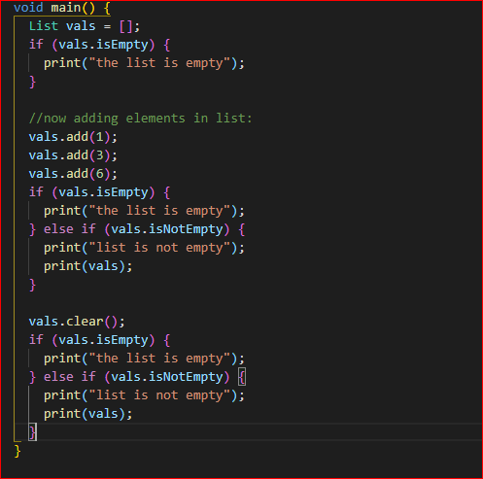

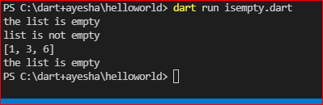

**REVERSE METHOD:**

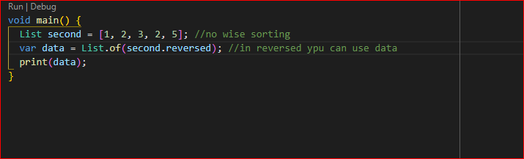

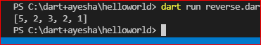

**ADD METHOD:**

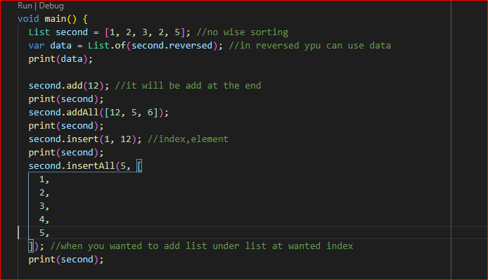

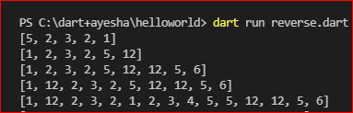

**REMOVE METHODS:**

